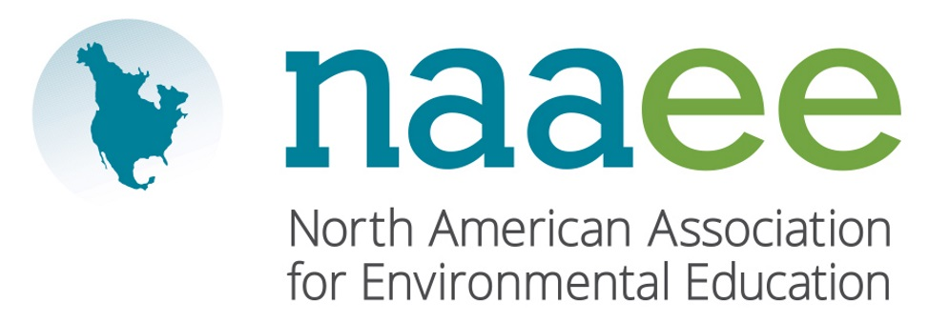
Contact Judy Braus  Telephone 202-419-0412  Email info@naaee.org  Website www.naaee.org | FOR IMMEDIATE RELEASE  October 16, 2017

John Jung Wins environmental education award

Local educator recognized by North American Environmental Education Association

Tempe, AZ, October 16, 2017– John Jung, environmental science teacher at Mesa High School, was recently recognized by the North American Association for Environmental Education (NAAEE) as the recipient of the K-12 Educator of the Year Award. The award is given to educators who promote environmental education and utilize the environment as a context for learning in their teaching.

Twenty years ago, Jung created the Environmental Science program at Mesa High School, making it an integral part of the school’s science curriculum. In 2007, Jung added an AP Environmental Science program to the school’s course offerings. Various organizations have recognized Jung for his innovation in the classroom, contributions to the field of environmental education, and development of a unique educational garden. Jung’s lifelong commitment to his students and the field of environmental education is a model for aspiring educators.

“John Jung exemplifies truly inspirational environmental educators who are the best in our field,” said Judy Braus, NAAEE’s Executive Director. “Our award winners are leading the way toward a more sustainable society from classrooms to communities across North America.”

This year, NAAEE presented 10 awards to outstanding individual and organizational leaders across North America. For a full list of 2017 winners, visit www.naaee.org/our-work/programs/awards.

About the North American Association for Environmental Education

For four decades, the North American Association for Environmental Education (NAAEE) has been dedicated to accelerating environmental literacy and civic engagement through the power of education. NAAEE supports a network of 20,000 educators and 56 regional affiliate organizations working in environmental education in more than 30 countries. For more information, visit www.naaee.org.

# # #

For more information, contact Judy Braus at 202-419-0412 or email at info@naaee.org.

