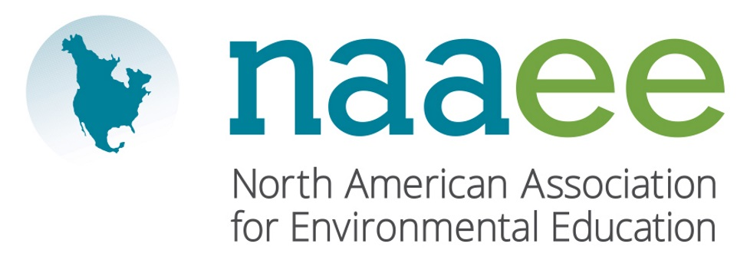
Contact Judy Braus  Telephone 202-419-0412  Email info@naaee.org  Website www.naaee.org | FOR IMMEDIATE RELEASE  October 16, 2017

Environmental Education Association of New Mexico Wins environmental education award

Local organization recognized by the North American Association for Environmental Education.

Albuquerque, NM, October 16, 2017– Environmental Education Association of New Mexico (EEANM), New Mexico’s professional association for the state’s environmental educators, was recently recognized by the North American Association for Environmental Education (NAAEE) for leadership in the environmental education field. EEANM was honored with the Outstanding NAAEE Affiliate Organization Award for their progress and development over the past year.

In 2016, EEANM led collaborative and engaging community environmental education initiatives. The organization co-hosted a statewide conference bringing together 200 educators with the New Mexico Science Teachers Association, New Mexico Council of Teachers of Mathematics, and the New Mexico Computer Science Teachers Association. EEANM spearheaded the creation and public adoption of New Mexico’s Environmental Literacy Plan (ELP), a blueprint for implementing environmental education in the public schools from pre-K through 12th grade. As 75 percent of New Mexico’s youth are youth of color, EEANM made a strong commitment to building diversity, equity, and inclusion to positively impact underserved local communities through environmental education.

“The Environmental Education Association of New Mexico exemplifies truly inspirational environmental educators and organizations,” said Judy Braus, NAAEE’s Executive Director. “Our award winners are leading the way toward a more sustainable society from classrooms to communities across North America.”

This year, NAAEE presented 10 awards to outstanding individual and organizational leaders across North America. For a full list of 2017 winners, visit www.naaee.org/our-work/programs/awards.

About the North American Association for Environmental Education

For four decades, the North American Association for Environmental Education (NAAEE) has been dedicated to accelerating environmental literacy and civic engagement through the power of education. NAAEE supports a network of 20,000 educators and 56 regional affiliate organizations working in environmental education in more than 30 countries. For more information, visit www.naaee.org.

# # #

For more information, contact Judy Braus at 202-419-0412 or email at info@naaee.org.

