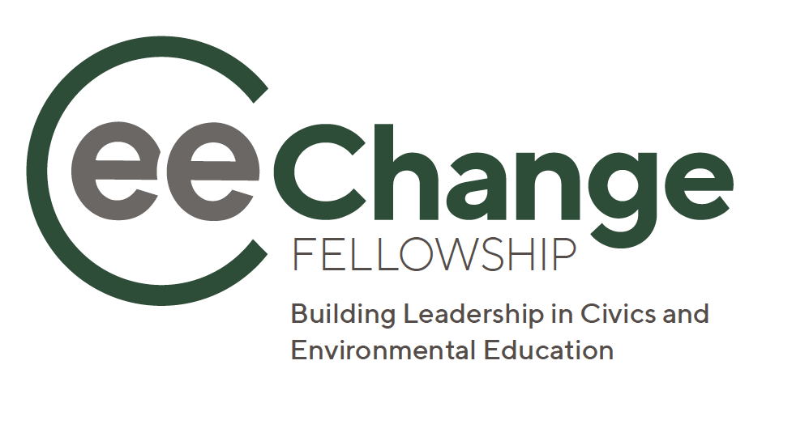
IMPORTANT: This is a copy of the application. Only applications submitted online through Submittable will be accepted: https://naaee.submittable.com/submit/b0f78581-65f2-420c-a8df-c6944808ae63/cee-change-fellows-2025/

Guidelines
Applications are due April 23, 2025, 11:59 PM U.S. ET.
The North American Association for Environmental Education (NAAEE) is now accepting applications for the 2025 CEE-Change Fellowship Program, NAAEE's latest initiative to support leadership and innovation in civics and environmental education across the world. CEE stands for Civics and Environmental Education. NAAEE recognizes the value in bringing together environmental and civic engagement educators to learn from each other and collaborate to scale up our impact as we work to create a more healthy and sustainable future.
For more information about the 2025 CEE-Change Fellowship and eligibility, please read through the full Request for Proposals. At this time, we can only accept U.S.-based applicants for the 2025–2026 cohort.
You will need to create a free Submittable account or sign in with Google or Facebook credentials to submit your online application.
- You can save a draft of your work if you would like to finish filling out the form at a later date.
- If anything changes with the information you submitted, please request to edit the submission
- Our platform works best on Google Chrome, Firefox, and Safari. Internet Explorer is not supported. Please make sure you are using a supported browser.
- You can download Firefox by following the instructions linked here.
- You can download Chrome by following the instructions linked here.
- We will follow-up with you about your submission by email. Please be sure to unblock notification emails from Submittable and check the email you used to sign up for your Submittable Account regularly.
- Check out the Submitter Resource Center or reach out to Submittable's Customer Support team with any technical questions here.
- For programmatic questions about the CEE-Change Fellowship, please contact us at CEEChangeFellow@naaee.org.
Please apply through this online application. If you are an individual with a disability, you may request a reasonable accommodation if you are unable or limited in your ability to apply for this fellowship on this site as a result of your disability. You can request reasonable accommodations by contacting us at CEEChangeFellow@naaee.org.

At this time, we can only accept U.S.-based applicants for the 2025–2026 cohort.

Eligibility
All applicants must have the following:
- Location — Be located within the United States.
- Experience — At least five years of experience in civic engagement (CE), environmental education (EE), or community engagement.
- Partner Organization — A partner organization. A partner organization can be an ee360+ Partner, NAAEE State Affiliate, or other community or national organization whose goals and practices make a positive contribution to the field of CE and/or EE. Applicants must submit a recommendation letter from their partner organization describing how they will work together to design and implement a Community Action Project. Partner organizations must also explicitly agree the Fellow can attend the in-person Leadership Institute August 24–29, 2025. In many cases an applicant’s partner organization is also their employer.
- Community Action Project— A creative idea for a Community Action Project that addresses a civic and environmental issue. The project should propose a new or innovative solution to a civic and environmental problem, including strategies for reaching new audiences, applying new pedagogy or instructional frameworks to improve student action, engaging new audiences in civic life, achieving greater impact in addressing community sustainability and resilience issues, or new strategies for developing effective partnerships. Applicants can present current projects but must describe how they will use the fellowship to add a new twist or strategy that will make the project more innovative and effective. Fellows will use fellowship training, networking, and resources to build on this vision.
- Recommendation Letters — Two letters of recommendation. One letter must come from the applicant’s partner organization. The other letter can come from any professional contact familiar with the applicant’s experience in CE, EE, community engagement, or other leadership experiences.
Please carefully read through the Request for Proposals for more information about the CEE-Change program and eligibility.
Do you have at least 5 years of relevant experience in civic engagement (CE), environmental education (EE), or community engagement?*
- Yes, I have at least 5 years of CE, EE, or community engagement experience.
- No, I have less than 5 years of CE, EE, or community engagement experience.

Do you have a partner organization?*
- Yes, I have a partner organization.
- No, I do not have a partner organization
- I'm still looking for a partner organization

Do you have a Community Action Project that addresses a civic and environmental issue?*
- I have a creative idea for a Community Action Project that addresses a civic and environmental issue.
- I do not have an idea for a Community Action Project that addresses a civic and environmental issue.

Personal Information
Name*

Organization*

Title

Email address*

Address

Phone number*

Professional Experience
Briefly describe your experience as a community leader, environmental educator, and/or civics educator. Include any relevant training, leadership experience, and professional and volunteer experience.* (max 400 words)
Why do you want to participate in the CEE-Change Fellowship?* (max 250 words)
Please upload your resume as a PDF. Resumes should be no more than 2 pages in length.*
Include links to any additional documents, videos, or social media pages you'd like to share with the review committee. These can include blogs, news mentions, education products you've developed, or any other supporting materials.

Civics and Environmental Education (EE) Community Action Project
As part of this fellowship, you will design a Civics and EE Community Action Project. Your project should propose a new or innovative idea that uses education to help to address a local, state, or national civic and environmental issue, such as strategies for reaching new audiences, achieving greater impact in addressing community resilience issues, or new strategies for developing effective partnerships. All projects must address a community need, lead to progress on civic engagement, and strengthen community resilience to address environmental concerns. You can present current and ongoing projects but must describe how you will use the fellowship to add a new twist or strategy that will make the project more innovative and effective.

Describe your idea for a Community Action Project. You will have opportunities to refine your ideas over the course of the fellowship.* (max 500 words)

Include the following:
- Target audience, including your experience engaging this particular audience
- Timeline
- Project goals and activities
- Short-term and long-term outcomes (What change do you expect to see if you implement your project activities?)
- How your project will address a civic/environmental issue and community need using environmental and civic education
- How you will engage your partner organization
- What is innovative about your project

Partner Organization
Applicants must submit a letter of support from their partner organization, describing how they will work together to design and implement a Community Action Project. Partner organizations must also explicitly describe organizational support for the Fellow to attend an in-person Leadership Institute August 24–29, 2025 and the 2025 NAAEE virtual conference November 3–6, 2025 (since the NAAEE Conference is virtual, each Fellow will have the flexibility to create their own schedule that best meets their needs). A partner organization is typically an applicant's employer and can be any community or national organization whose goals and practices make a positive contribution to the field of CE and/or EE.

Partner Organization*

Main contact at Partner Organization*

Partner email address*

Partner address

Please upload your partner letter of support as a PDF file. *

Professional Reference
We require a recommendation letter from a professional reference for this application. Reference should be familiar with your professional and leadership experience and describe why you would be a great candidate for this fellowship.

Professional reference name*

Professional reference title and organization*

Professional reference email address*

Please upload your reference letter as a PDF file.*

Training Opportunities
This fellowship will have a number of in-person and virtual training opportunities.

If selected, are you able to attend the in-person Leadership Institute August 24–29, 2025? All travel, food, and lodging expenses will be covered by the fellowship program.*
- Yes
- No
- Don’t know

Please describe any special considerations regarding your schedule.

What specific skills, professional development, and learning opportunities would be most relevant to your work as an environmental and/or civics educator?*
Fellows will receive professional development opportunities from a variety of leaders in the fields of conservation, community resilience, environmental education, civics, communication, and other disciplines. Fellows will also learn and share with each other. What specific skills and experiences would you bring to this fellowship?*

Six Month Extension
Fellows will be given the opportunity to request an optional six-month extension, extending the fellowship through December 2026. Please describe your initial interest in the extension opportunity. Formal extensions will be made in the last 3 months of the fellowship.*
- Yes, I’m interested in the extension opportunity
- No I’m not interested in the extension opportunity
- I’m not sure at this time

Additional Information
Is there any other information you would like to share with the review committee about your interest in this fellowship? (max 250 words)

How did you hear about this fellowship?
- eeNEWS (NAAEE's biweekly newsletter)
- eePRO
- Social media
  - From which social media platform?
- Friend/colleague
  - From which friend/colleague?
- Search engine (e.g. Google, Bing)
- Another blog/newsletter/website
  - From which blog/newsletter/website?
- Other
  - Please share how you heard about the program.

If you have questions about your application, please send us a note at CEEChangeFellow@naaee.org.

