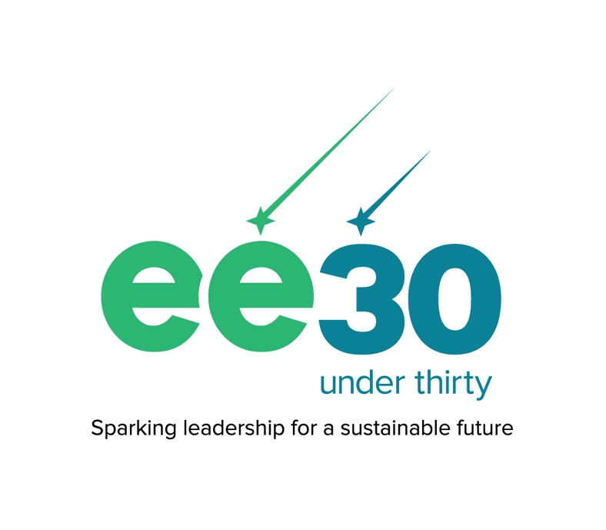
EE 30 Under 30 2025 Nomination Form

Self-Nomination

IMPORTANT: This is a copy of the application. Only applications submitted online through Submittable will be accepted: https://naaee.submittable.com/submit/148c5114-c523-4f70-a950-7b96a28530a1/ee-30-under-30-class-of-2025

Apply by May 12, 2025

Guidelines

EE 30 Under 30 recognizes young people across the globe who are building a sustainable future through education. Nominate yourself or someone you know today!

Young people around the world are creating lasting change for both people and the planet. EE 30 Under 30 shines the spotlight on these changemakers who demonstrate passion, commitment, and leadership using environmental education. The EE 30 Under 30 Class of 2025 will receive global recognition, join a growing community of inspiring EE leaders, and have access to ongoing opportunities for professional development and networking.

Environmental education (EE) and leadership show up in many different forms! We aim to recognize leaders with a wide range of backgrounds who are bringing new constituencies and insights to EE. We highly encourage nominees from across sectors and disciplines to apply. We welcome nominees who are:
- Working at any scale: local, national, regional, or global, in rural or urban contexts, just to name a few!
- In any position or role: community organizer, director, consultant, artist, teacher, and much more.
- Using education in any context: in schools, businesses, communities, church groups, networks, government, the media—you name it!
Eligibility:
- Nominees must be 30 years old or younger (as of May 12, 2025). If you are over 30, you can still nominate someone else!
- Nominees can come from anywhere in the world!
- Nominations must be in English, but your nomination will not be judged based on your English language ability.
- Nominees must be using EE to address sustainability issues, build a more resilient environmental movement, and/or create healthier and more civically-engaged communities. Read more about key elements of EE here.
- Nominees must demonstrate some leadership in EE, but you do not need to be in a leadership position to demonstrate leadership! This can include (but is not limited to) inspiring others to take action towards a shared vision, listening to and taking action for the needs of your community, innovating in the face of challenges, and welcoming everyone to participate and engage, and much more.
We highly encourage you to use your own words and not rely on AI-generated content, including written responses from Chat GPT or other AI platforms. We will not consider videos that are AI-generated.

Video requirement: All nominees need to submit a short introduction video (90 seconds max) and provide a letter of support. Please take a close look at the application, whether you are nominating yourself or someone else, to understand these requirements.

Applicant webinar: Register for our 2025 Applicant Webinar on April 9 at 10:00 AM U.S. Eastern Time (find your time zone here) to learn more about the program and some tips for submitting a strong nomination.

About EE 30 Under 30: Since 2016, NAAEE's EE 30 Under 30 program has recognized 271 individuals from 53 countries who are making a difference through environmental education. To address today’s complex challenges, we need a wide range of perspectives, skills, and experiences. EE 30 Under 30 celebrates the unique and passionate leadership of talented young leaders around the world and gives them a professional boost to increase their impact. Each year our awardees join a growing alumni network of inspiring environmental education leaders and receive ongoing opportunities to network, grow professionally, and promote their work. This program is made possible by the Global Environmental Education Partnership (GEEP). For more information about the program and to read alumni biographies, visit naaee.org/ee30under30.

Check out our FAQ at https://naaee.org/EE30U30-FAQ, and please direct any questions to ee30u30@naaee.org. If you experience any technical issues, please contact Submittable here.

About submitting through Submittable
You will need to create a free Submittable account or sign in with Google or Facebook credentials to submit your online application.

If you are an individual with a disability, you may request a reasonable accommodation if you are unable or limited in your ability to apply for this award on this site as a result of your disability. You can request reasonable accommodations by contacting ee30u30@naaee.org.

Only submissions in English will be considered.

Nomination Form

CONTACT INFORMATION

Nominee Contact Information
Nominee name*

Nominee position/title (if applicable)*

Nominee organization/affiliation (if applicable)*

Nominee city/town*

Nominee state/province

Nominee country/territory* (Please contact ee30u30@naaee.org if you don’t see your country/territory listed)

Nominee email*

Nominee phone number* (including country code)

Age of nominee (as of May 12, 2025)* Important: To be eligible, the nominee must be 30 years old or under on May 12.

Are you applying for a joint EE 30 Under 30 award with another nominee (e.g., your co-founder, colleague, etc.)? Joint nominations are only considered for nominees with very closely aligned initiatives/experiences.
- Yes, I’d like to be considered for a joint award with another nominee.
  - Name of joint nominee:
  - Joint nominees are required to submit individual nominations. For any questions, please reach out to us at ee30u30@naaee.org.
- No, I’d like to be considered for an individual award only.

NOMINEE’S WORK AND IMPACT

A. Please upload a short video introducing yourself and your story. (90 seconds max)*
😀 This can include anything you would like to share about your background, identity, passions, or anything else in relation to this award. Your nomination will not be judged based on your English language ability.
🙁 Please refrain from listing off past awards or recognitions—we do not consider past awards in our selection process.
🎵Any music or photos used in your pitch must be free of copyright. Please provide links or other proof that any third-party content used in your pitch is copyright-free.
🎤 If recorded in a language other than English, please provide an English transcript or subtitles. If your video includes words that are not translatable to English, please write out the full spelling of the word in the subtitle or transcript.

File size upload limit: 800mb. Upload may take several minutes.

Is there anything else you'd like to share with us about yourself and your story that isn't mentioned in your video? (optional) (Limit: 200 words)
😀 This can include anything you would like to share about your background, identity, passions, or anything else in relation to this award. Your nomination will not be judged based on your English language ability.
🙁 Please refrain from listing off past awards or recognitions—we do not consider past awards in our selection process.

B. How do you use environmental education (EE) to engage people in building a sustainable future? Be sure to include your goals, activities/approaches, audience, and any positive outcomes you’ve seen from your work so far. Be clear about how you specifically contributed to any activities you describe (for example, if you are part of a team, highlight your specific contribution).* (Limit: 350 words)
For more information about environmental education (EE), please visit https://naaee.org/about/ee or review our eeLEARN module "What is EE?"

C. Please describe your leadership qualities and share specific examples of how those qualities show up in your work.* (Limit: 350 words)
😀 Leadership examples can include (but are not limited to):
- Building partnerships and fostering collaboration
- Promoting a clear, shared vision for change in your community
- Adapting to change and uncertainty
- Finding innovative solutions to challenges
- Welcoming everyone to participate and engage
- Mentoring or coaching others
- Listening to the needs of your community, colleagues, or others

D. Why do you want to join the EE 30 Under 30 community? Please share both how you might benefit from AND what you might contribute to the community, which thrives on active engagement from our awardees and alumni.* (Limit: 200 words)
Feel free to include anything else you would like to share to support your nomination.

LETTER OF SUPPORT (see Letter of Support below)
Provide an email address for a reference who can share about you as a leader. Your reference must fill and submit the form before the application deadline for their letter to be considered.*
When you enter their email and click “Send request now,” they will receive an email from notifications@email.submittable.com to fill and submit a brief form. We must receive their submission before the deadline of May 12 at 11:59 PM U.S. Eastern Time.

AFFILIATIONS AND WEBPAGES

List your affiliations with any additional organizations, networks, or programs. Include the organization/program name and website (if possible) and how you’re affiliated (e.g. volunteer, staff, board member, advisor, etc.).

List any social media or other web pages for the nominee and/or their organization.
😀 This could include LinkedIn, Facebook, Bluesky, Instagram, YouTube, or other sites.

HOW YOU HEARD ABOUT EE 30 UNDER 30

How did you hear about EE 30 Under 30?
- eeNEWS (NAAEE's biweekly newsletter)
- eePRO
- GEEP newsletter
- Social media
  - From which social media account:
- Friend/colleague
  - From which friend or colleague:
- Search engine (e.g. Google)
- Another blog/newsletter/website
  - From which blog/newsletter/website:
- I’m an EE30U30 alum
- Other
  - Please specify:

*required

Letter of Support

Thank you for your time to provide a reference for this nominee for EE 30 Under 30, a program of the North American Association for Environmental Education (NAAEE) that each year recognizes 30 exceptional young leaders around the world who are using environmental education to create change in their communities. We look for nominees who show a commitment to environmental education and demonstrate leadership through their work and appreciate your insights into this nominee's impact and leadership. The 2025 awardees will join a growing international community of inspiring young leaders, with year-round opportunities for professional development and networking to boost their careers. Learn more about the EE 30 Under 30 program at https://naaee.org/programs/ee-30-under-30.

Please provide your contact information below and then share why this nominee should be recognized with this award. For any questions or concerns, please contact ee30u30@naaee.org.

Please submit your reference letter by May 12, 2025 at 11:59 PM U.S. Eastern Time.
Name*

Position/title (if applicable)*

Organization/affiliation (if applicable)*

Email*

Phone number* (including country code)

Relationship to Nominee*

Please share why you think this nominee should be named an EE 30 Under 30.* (Limit: 350 words)
😀 This can include anything you would like to share about their background, identity, passions, or anything else in relation to this award.
🙁 Please refrain from listing off past awards or recognitions—we do not consider past awards in our selection process.

*required

