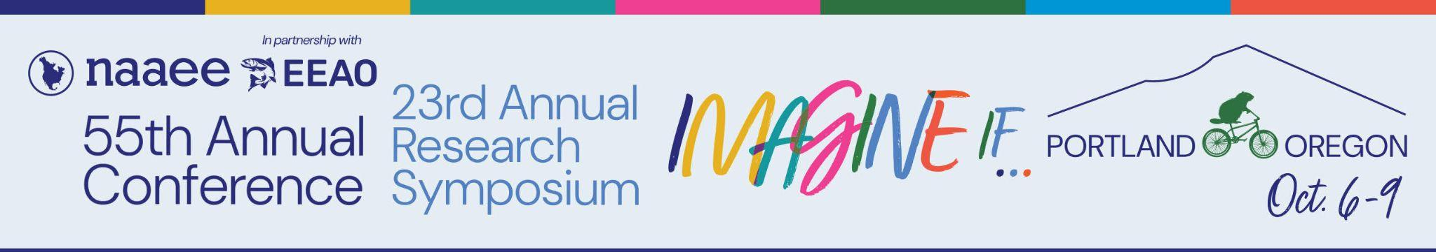

Rosa Parks and Grace Lee Boggs Outstanding Service

2026 Award Nomination Form
The Rosa Parks and Grace Lee Boggs Outstanding Service Award is presented annually to an individual in recognition of their leadership in educating and promoting action to support environmental education and environmental justice at the local, state, or global level.
The award recognizes a person who demonstrates the values and inner strength of Rosa Parks and Grace Lee Boggs. Both Parks and Boggs were unwilling to stand by as they and others suffered injustices because of their skin color or heritage. Rosa Parks worked tirelessly to address social injustices while Grace Lee Boggs worked to remedy environmental injustices (scroll to bottom of page for more detailed information on both leaders).
The award recipient must have made significant contributions to environmental education efforts focused on the key attributes of sustainability as defined in the 1977 Tbilisi Declaration, including environmental, economic, and social issues, with an emphasis on environmental health, environmental justice, poverty, jobs, and other issues that impact people of color, under-served audiences, urban audiences, and others who have been disenfranchised. This award is also designed to recognize individuals and organizations who are working to make environmental education more relevant to the lives of all global citizens.
The recipient should display or have made one or more of the following contributions:
- Used environmental issues or situations for motivating youth considered underrepresented in the environmental movement (as defined above) to reach their highest potential by providing them with hands-on experiences that build practical day-to-day life skills;
- Used environmental education to empower community residents to address local environmental concerns;
- Dedicated to service and leadership that encourages the participation of a diversity of audiences in environmental education;
- Made visible contributions in environmental education by promoting diversity and equity through research, innovation, curricula, legislation, publications, or advocacy;
- Used environmental education to work with individuals considered underrepresented in the environmental movement and the field of environmental education; and
- Demonstrated excellence in educating the public about environmental issues as they relate to social justice, health, community well-being, and environmental justice through print, electronic, or visual media.

About Rosa Parks
Rosa Parks spent her life as a civil rights leader advocating so that others could learn to “reach their highest potential” regardless of their ethnicity or heritage. Mrs. Parks was known for her "quiet strength," which the Rosa and Raymond Parks Institute for Self Development uses to engage and empower youth in hands-on experiences to build practical day-to-day living skills.
The Rosa and Raymond Parks Institute for Self Development promotes a multicultural curriculum and participation in activities that provide cross-cultural perspectives. Their chapters and learning centers are represented in the United States, Bahamas, and Canada. One of their goals is to instill “a global and inclusive perspective.” To read further about Mrs. Parks and the Rosa and Raymond Parks Institute for Self Development visit: www.rosaparks.org

About Grace Lee Boggs
Grace Lee Boggs, the daughter of Chinese immigrants and a doctoral Ivy League graduate in philosophy, believed in “the power of ideas to change ourselves and our reality.” Living to be 100 years old and passing on October 5, 2015, Dr. Boggs was an active organizer at the grassroots level to revitalize communities.
Dr. Boggs’ was well known in her hometown of Detroit, where her friends created the Boggs Center to Nurture Community Leadership. But her reach extended far beyond Detroit, with an appearance on the Bill Moyers Journal on PBS and her environmental justice efforts to encourage urban gardening as a way to sustain ourselves, build community, and reduce global warming. To read further about Dr. Boggs visit: www.boggscenter.org

Please note: Nominations may only be submitted by NAAEE members. If you are interested in becoming a member, find information here. If you need technical support with this form, please email eepro@naaee.org. If you have any questions about the NAAEE Awards for Excellence, please contact Brenda Metcalf at Brendasmetcalf@aol.com.
Please fill out this form and email it, along with any required additional documentation, to NAAEE at awards@naaee.org by July 17, 2026.

Nominee Contact Information
Name of Person Nominated (Please enter as you would like to see it on the award)

Title of Person Nominated:
Country of Person Nominated:
Email of Person Nominated:
Phone Number of Person Nominated:

Nominee Details
Please provide a brief summary (maximum 50 words) of the accomplishments of the individual nominated. (This summary will be used for PR purposes and at the Awards Ceremony.):

Please provide an explanation of this individual’s accomplishments. Be sure to address when these accomplishments were made and specific reasons why you believe these accomplishments demonstrate leadership to educate about and promote action that addresses environmental justice concerns at the local, regional, or global level. (500-word limit)

When submitting this form, please also send letters of support (maximum of three files) and supplemental documentation in PDF or Word format.

Nominator Information
Nominator’s Name (Please enter your first and last name. Nominator must be a member of NAAEE or must have a co-nominator who is a member.):
Nominator’s Title:
Nominator’s Organization:
Nominator’s Country:
Nominator’s Email:
Nominator’s Phone Number:
Are you currently a member of NAAEE?
Do you have a co-nominator?
Is your co-nominator a member of NAAEE?
What is the name of your co-nominator? (Write N/A if you do not have a co-nominator.)

What is the email address of your co-nominator? (Write N/A if you do not have a co-nominator.)

