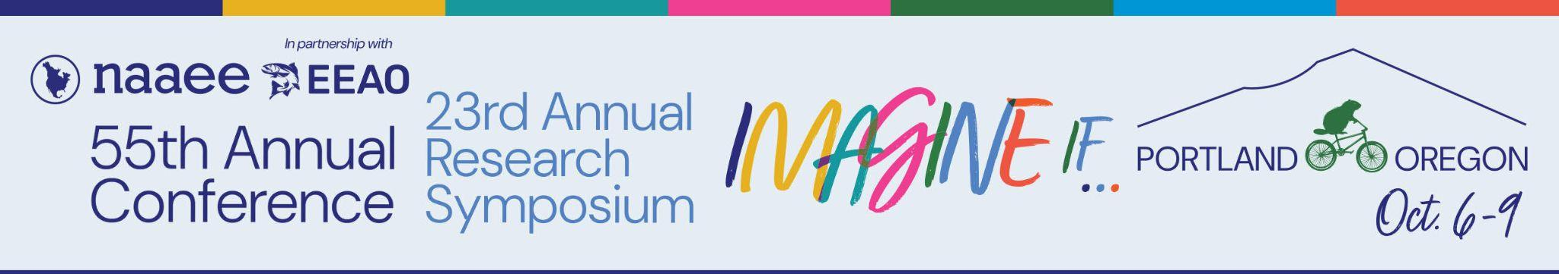

Walter E. Jeske

2026 Award Nomination Form
The Walter E. Jeske Award is NAAEE’s most prestigious award, given each year to recognize service to NAAEE and leadership within the field of environmental education. This award was established to honor Walt Jeske, Chief of the Education and Publications Unit with the U.S. Soil Conservation Service. Jeske was a dedicated member of the NAAEE Board of Directors, and an outstanding environmental educator until his death in 1981.
Qualifications for this award include:
- An active NAAEE member with at least five years of membership;
- Occupies, or has occupied, a leadership role in NAAEE and has made leadership contributions to the field of EE in addition to contributions emanating directly from her/his/their salaried duties;
- Must have received clear recognition of her/his/their overall contributions among EE colleagues and within NAAEE; and
- Must have worked in the field of EE for at least 15 years.
Please note: Nominations may only be submitted by NAAEE members. If you are interested in becoming a member, find information here. If you need technical support with this form, please email eepro@naaee.org. If you have any questions about the NAAEE Awards for Excellence, please contact Brenda Metcalf at Brendasmetcalf@aol.com.
Please fill out this form and email it, along with any required additional documentation, to NAAEE at awards@naaee.org by July 17, 2026.

Nominee Contact Information
Name of Person Nominated (Please enter as you would like to see it on the award):
Title of Person Nominated:
Country of Person Nominated:
Email of Person Nominated:
Phone Number of Person Nominated:

Nominee Details
Please provide a brief summary (maximum 50 words) of the accomplishments of the individual nominated. This summary will be used for PR purposes and at the Awards Ceremony.

Please provide an explanation of this individual’s accomplishments. Be sure to address the following in your explanation: (1) When were these accomplishments made? (2) Why, specifically, do you believe these accomplishments represent distinguished service to the cause of EE or to EE research? (500-word limit)

When submitting this form, please also send letters of support (maximum of three files) and supplemental documentation in PDF or Word format.

Nominator Information
Nominator’s Name (Please enter your first and last name. Nominator must be a member of NAAEE or must have a co-nominator who is a member.):
Nominator’s Title:
Nominator’s Organization:
Nominator’s Country:
Nominator’s Email:
Nominator’s Phone Number:
Are you currently a member of NAAEE?
Do you have a co-nominator?
Is your co-nominator a member of NAAEE?
What is the name of your co-nominator? (Write N/A if you do not have a co-nominator.)

What is the email address of your co-nominator? (Write N/A if you do not have a co-nominator.)

